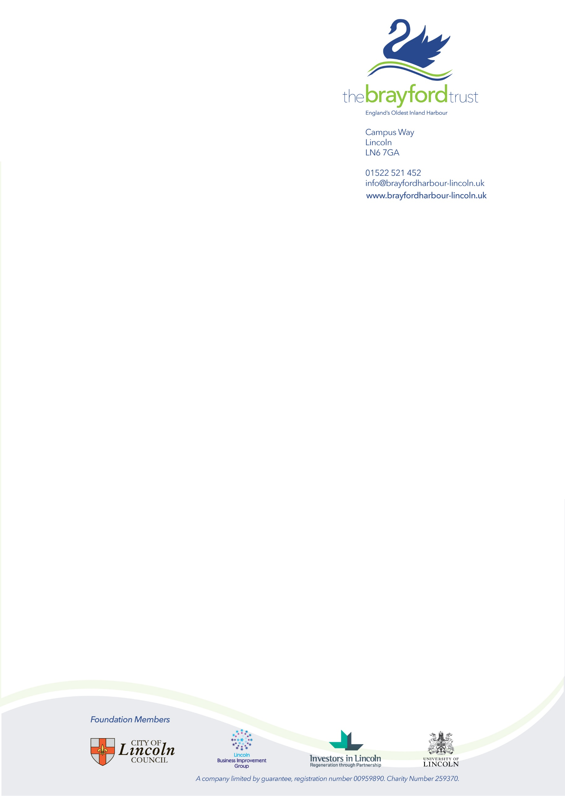Brayford Harbour

Mooring Application (2023)

Date of Application ……………………………...

**OWNER INFORMATION**

Name: ..............................................................

Address: ....................................................................................................................................

...................................................................................................................................................

...........................................................................................Postcode.........................................

Email: ........................................................................................................................................

Tel No: Mobile: ................................................................... Home: ..........................................

**BOAT INFORMATION**

Type: Cruiser / Narrowboat / Other Engine: Petrol / Diesel / Electric

Boat Name: ...............................................................................................................................

Make: …………………………………………. Model: ……………...…………………….………...

LOA: .................................. Beam: ............................... Draft: ……………………...……….

Insurance Expiry Date: …………………… CRT Licence No. …………….……………………

BSSER- …………. /…….

**MOORING REQUIRED**

**Leisure Mooring** **Winter Mooring** **Visitor Mooring**

**Preferred start date:** ……………………………………………………………………………….

Please send the completed application form to the Harbour Office along with your supporting documents.

Applications can only be processed once all the documents have been received.